SIMATS ENGINEERING
ASSESSMENT TOOL 1: Knowledge Representation Design Assessment
COURSE NAME: ARTIFICIAL INTELLIGENCE COURSE CODE: MLA01
AND EXPERT SYSTEMS

COURSE OUTCOME COVERED
CO3: Implement propositional and first-order logic using resolution, unification, and inference techniques for knowledge representation and reasoning.(BTL 3)
Assessment Tool Weightage: 40 %

Total Marks: 100 Time: 60 Mins
No. of Questions: 5
Annexure A
Knowledge Representation Design Assessment

Code of Conduct:

I P Dinesh Reddy / 192525399 (Name / Reg No) certify that this submission is my original work and that I have adhered to the guidelines specified for this assessment. I understand that any violation of academic integrity rules will result in disciplinary action.
Signature of the student:

Criterion | Weightage | Marks Obtained
1. Problem Analysis and Domain Understanding | 10%
2. Knowledge Engineering and Knowledge Base Design | 15%
3. Propositional Logic Representation | 10%
4. First-Order Logic Representation | 15%
5. Unification and Resolution | 15%
6. Forward and Backward Chaining | 15%
7. Inference and Reasoning Accuracy | 10%
8. System Architecture / Representation Diagram | 5%
9. Prototype Implementation and Results | 5%
Total | 100%

Signature of the Faculty Total Marks Awarded

Smart Healthcare Diagnosis System
A hospital wants to develop an AI-based system that can identify possible illnesses from patient symptoms. The system contains facts such as:
- Ravi has fever.
- Ravi has cough.
- Ravi has body pain.
- Patients with fever and cough may have flu.
- Patients with flu and body pain may have viral infection.
- Patients with viral infection should be advised to rest.
Task:
- Represent the given knowledge using Propositional Logic.
- Convert the knowledge into First-Order Logic (FOL).
- Construct a knowledge base containing facts and rules.
- Demonstrate unification for at least two predicates.
- Use forward chaining to determine Ravi's condition.
- Use backward chaining to prove whether Ravi needs rest.
- Demonstrate resolution for one selected query.
- Explain the final inference produced by the system.

Smart Healthcare Diagnosis System

1. Problem Analysis
Objective: Identify Ravi’s possible illness and provide an appropriate recommendation using knowledge representation and inference.
Initial facts:
- Ravi has fever.
- Ravi has cough.
- Ravi has body pain.
Inference: Fever + cough → Flu; Flu + body pain → Viral infection; Viral infection → Rest.

2. Propositional Logic Representation
Let:
- F = Ravi has fever
- C = Ravi has cough
- B = Ravi has body pain
- L = Ravi has flu
- V = Ravi has viral infection
- R = Ravi should rest
Facts
F, C, B
Rules
- F ∧ C → L
- L ∧ B → V
- V → R
Therefore:
F ∧ C ∧ B → L → V → R

3. First-Order Logic Representation
Facts
- Fever(Ravi)
- Cough(Ravi)
- BodyPain(Ravi)
Rules
Rule 1:
∀x [Fever(x) ∧ Cough(x) → Flu(x)]
Rule 2:
∀x [Flu(x) ∧ BodyPain(x) → ViralInfection(x)]
Rule 3:
∀x [ViralInfection(x) → Rest(x)]
These rules represent the relationships given in the assessment.

4. Knowledge Base
No. | Type | Knowledge
F1 | Fact | Fever(Ravi)
F2 | Fact | Cough(Ravi)
F3 | Fact | BodyPain(Ravi)
R1 | Rule | Fever(x) ∧ Cough(x) → Flu(x)
R2 | Rule | Flu(x) ∧ BodyPain(x) → ViralInfection(x)
R3 | Rule | ViralInfection(x) → Rest(x)
Knowledge Base = Facts + Rules

5. Unification and Substitution
Unification 1
Predicates:
Fever(x) and Fever(Ravi)
Substitution:
{x/Ravi}
Hence:
Fever(x) = Fever(Ravi)
Unification 2
Predicates:
Flu(x) and Flu(Ravi)
Substitution:
{x/Ravi}
Hence:
Flu(x) = Flu(Ravi)
Most General Unifier (MGU): {x/Ravi}

6. Forward Chaining
Forward chaining starts from known facts and derives new facts.
Step 1:
Fever(Ravi) + Cough(Ravi)
Using Rule 1:
Flu(Ravi)
Step 2:
Flu(Ravi) + BodyPain(Ravi)
Using Rule 2:
ViralInfection(Ravi)
Step 3:
ViralInfection(Ravi)
Using Rule 3:
Rest(Ravi)
Forward-Chaining Result
Ravi → Flu → Viral Infection → Rest

7. Backward Chaining
Query: Rest(Ravi)
Start with the goal:
Rest(Ravi)
Rule 3 requires:
ViralInfection(Ravi)
To prove this, Rule 2 requires:
Flu(Ravi) ∧ BodyPain(Ravi)
To prove Flu(Ravi), Rule 1 requires:
Fever(Ravi) ∧ Cough(Ravi)
Both are available as facts, and BodyPain
(Ravi) is also available.
Therefore:
Fever(Ravi) + Cough(Ravi) → Flu(Ravi)
Flu(Ravi) + BodyPain(Ravi) → ViralInfection(Ravi)

ViralInfection(Ravi) → Rest(Ravi)
Backward-Chaining Result
Rest(Ravi) is proved.

8. Resolution
Query
Prove:
ViralInfection(Ravi)
Rule 2:
Flu(x) ∧ BodyPain(x) → ViralInfection(x)
Convert to clause form:
¬Flu(x) ∨ ¬BodyPain(x) ∨ ViralInfection(x)
For Ravi:
¬Flu(Ravi) ∨ ¬BodyPain(Ravi) ∨ ViralInfection(Ravi)
Given:
Flu(Ravi)
Resolve:
¬BodyPain(Ravi) ∨ ViralInfection(Ravi)
Given:
BodyPain(Ravi)
Resolve again:
ViralInfection(Ravi)
Hence, the query is proved by resolution.

9. Final Inference
The inference engine processes Ravi’s symptoms using the rules in the knowledge base:
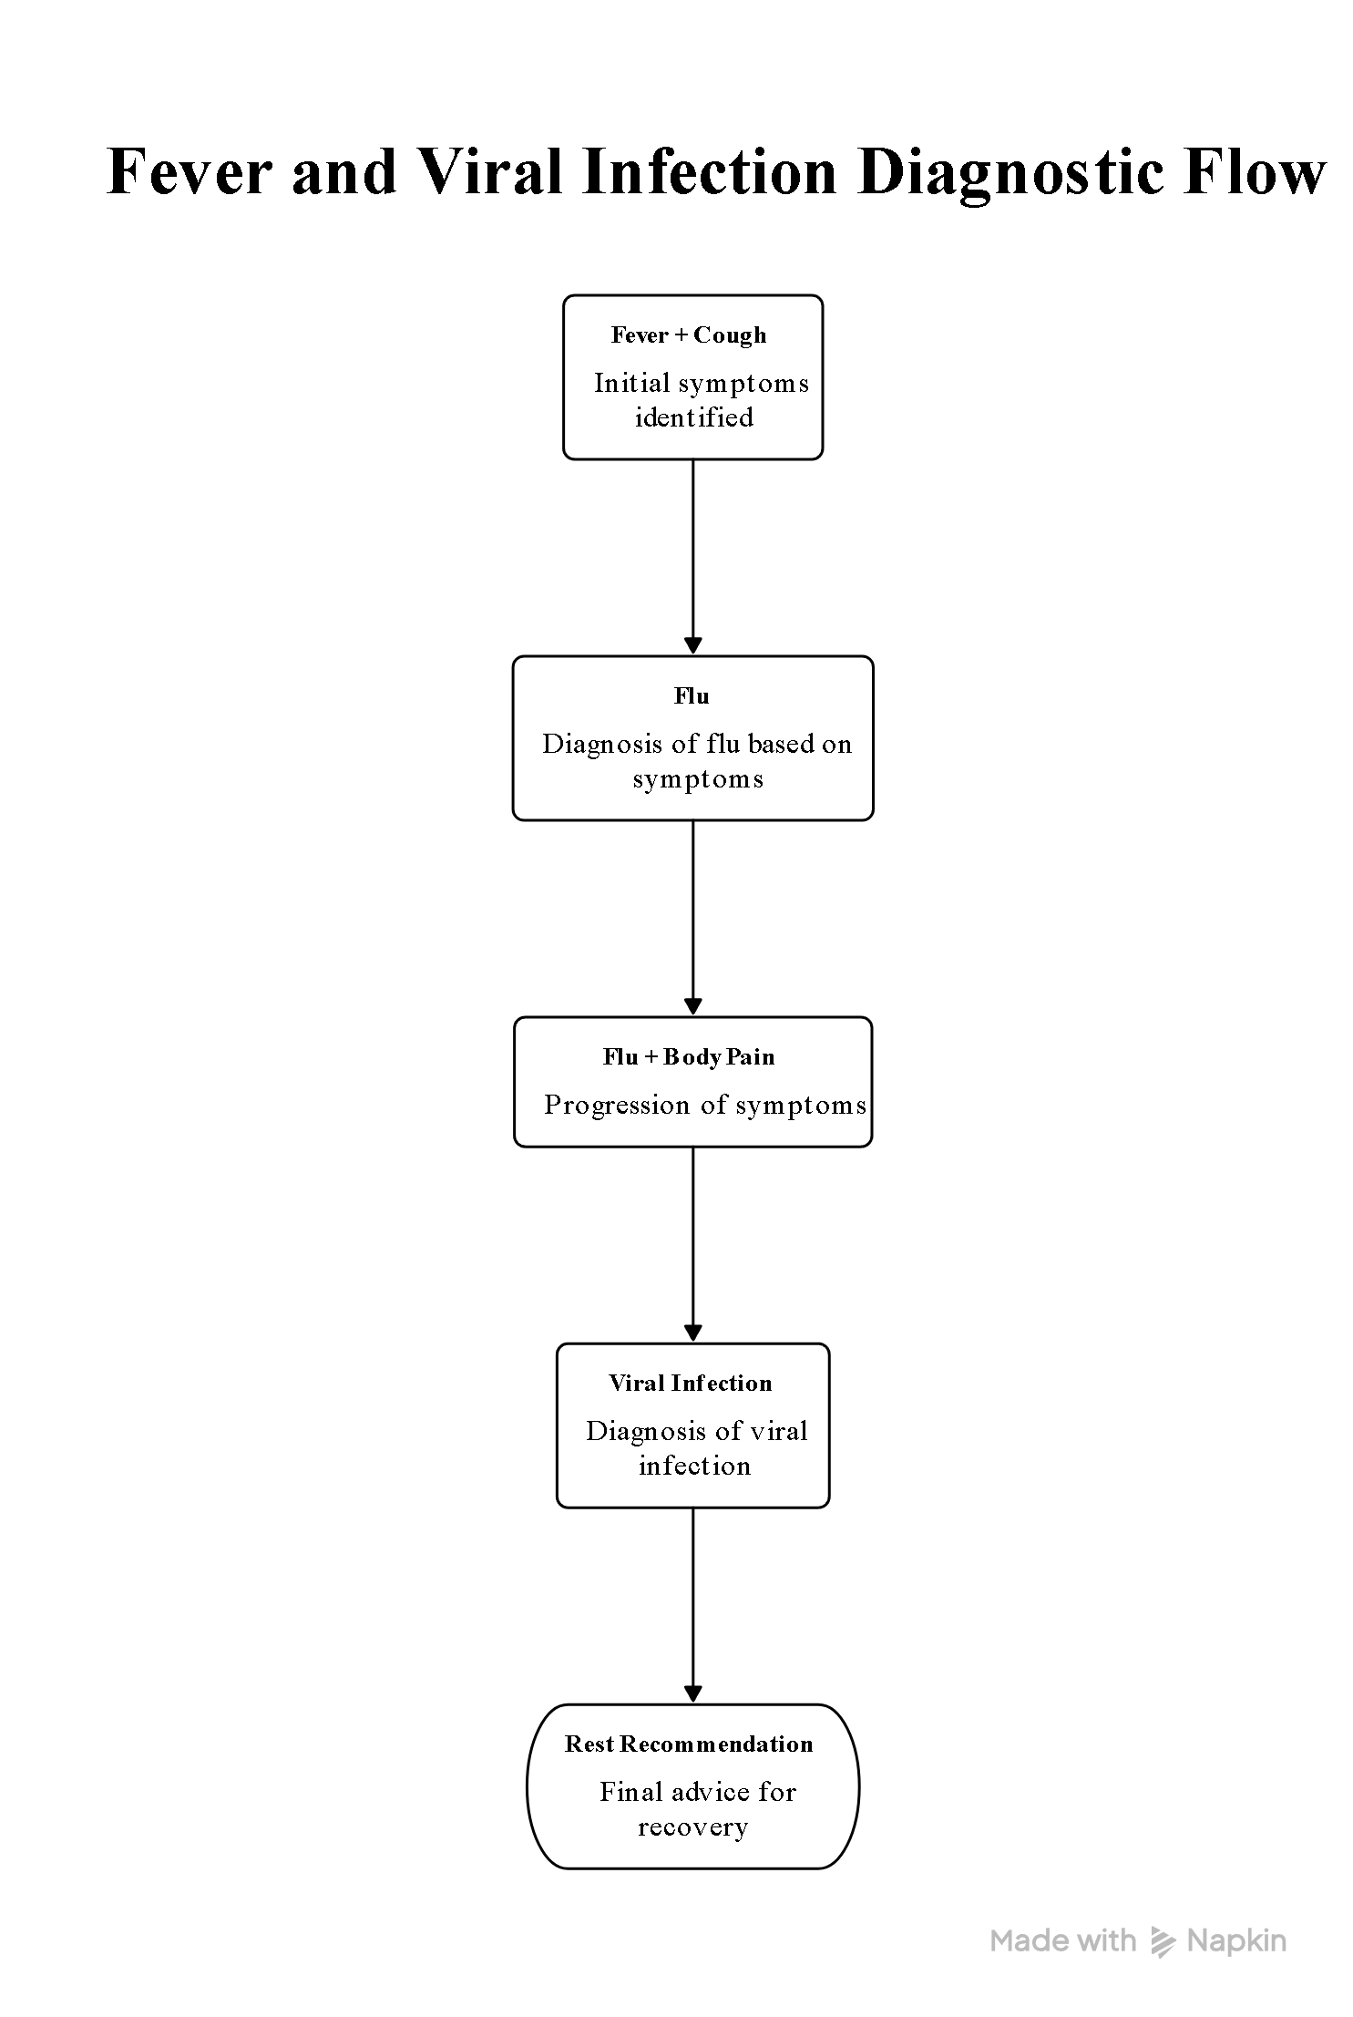

System Architecture Diagram
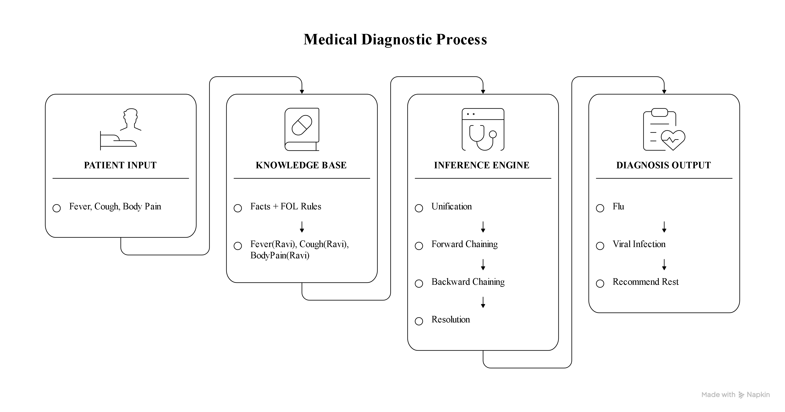

Final Conclusion
The system infers that Ravi may have a viral infection and should be advised to rest.
This directly satisfies the assessment requirement to explain the final inference produced by the system.

Evaluation Rubrics:

Criterion | Weightage  (%) | Excellent | Good | Average | Poor
Problem Analysis and  Understanding | 15% | 13–15% – Clearly understands and analyzes the real-world problem, objectives, entities, facts, constraints, and expected inference. | 10–12% – Understands the problem with minor omissions. | 7–9% –  Shows partial understanding with some. | 0–6% – Poor or incorrect understanding of the problem.
Knowledge  Engineering &  Knowledge Base | 15% | 13–15% – Develops a complete, consistent, and well-structured knowledge base with appropriate facts, predicates, entities, and rules. | 10–12% – Knowledge  base is well designed with. | 7–9% – Basic knowledge base is developed but several | 0–6% – Knowledge base is incomplete, inconsistent, or
Propositional &  First-Order Logic Representation | 20% | 17–20% – Correctly represents the domain using propositions, predicates, variables, constants, quantifiers, and logical connectives with excellent accuracy. | 13–16% – Logic representati on is mostly correct with minor errors. | 9–12% – Provides basic representatio ns but has several logical or. | 0–8% – Logic representation is incorrect, incomplete, or missing.
Unification &  Resolution | 15% | 13–15% – Correctly performs substitutions, identifies the MGU, and applies resolution systematically to derive valid conclusions. | 10–12% – Applies unification and resolution | 7–9% –  Demonstrates  partial understanding | 0–6% – Unable  to correctly apply unification or resolution.
Forward Chaining  & Backward  Chaining | 15% | 13–15% – Correctly applies both forward and backward chaining with clear step-by-step reasoning and appropriate rule selection. | 10–12% –  Correctly applies both methods with minor | 7–9% –  Demonstrates  partial understanding of | 0–6% –  Incorrectly applies or fails to demonstrate
Inference &  Reasoning  Accuracy | 10% | 9–10% – Produces logically valid conclusions and clearly explains how facts and rules lead to the final inference. | 7–8% – Conclusions are mostly correct with minor | 5–6% – Some correct inferences but reasoning is | 0–4% –  Conclusions are incorrect, unsupported, or
Knowledge  Representation  Diagram / | 5% | 5% – Provides a complete, accurate, well-labelled diagram showing knowledge base, inference engine, | 4% – Diagram is mostly correct with minor | 3% – Diagram  is partially  complete or | 0–2% –  Diagram is missing or
Originality, Critical  Thinking &  Presentation | 5% | 5% – Demonstrates excellent independent thinking, appropriate real-world application, comparison of reasoning approaches, and clear presentation. | 4% – Demonstrate s good reasoning and clear presentation  . | 3% – Shows  limited critical thinking and basic presentation. | 0–2% – Shows  little originality,  weak reasoning, or poor presentation.

